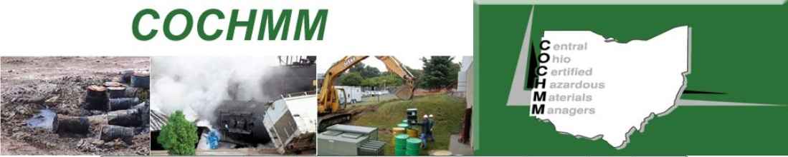

COURSE:
Respirable Crystalline Silica

DATE / TIME:
Monday, August 17th
11:00am – 12:00pm

COURSE COST:
Free

REGISTRATION:
Enter your name, title, and email address upon logging into the webinar

SPEAKER INFORMATION:
Heather Tibbitts, CSP
Project Manager
Safex, Inc.
614-890-0800 x206
hrtibbitts@safex.us

COCHMM
www.cochmm.org

FREE COCHMM Webinar –
Crystalline Silica Standard Updates!

The Central Ohio Chapter of Certified Hazardous Materials Managers is hosting a lunch-time Health and Safety Webinar on August 17, 2020. The webinar will be held from 11:00am – 12:00pm.

The presenter reviews the requirements of the Respirable Crystalline Silica Standard per the Occupational Safety and Health Administration (OSHA). The presentation will provide an overview of the silica standard as well as information and guidance on the recent implementation of employee medical surveillance for General Industry.

We will also overview membership and benefits of joining the Central Ohio Certified Hazardous Materials Managers chapter and our upcoming calendar of events!

Learning Objectives:
- Define crystalline silica and identify work sites / common routes of exposure,
- Describe the hazards posed by silica dust and silica dust exposure,
- Explain how to prevent silica exposure through engineering controls, work practices, and personal protective equipment, and
- Understand medical surveillance and record keeping requirements.

Cost:
- FREE to call in and attend!

Call in Information:

Please join my meeting from your computer, tablet, or smartphone.
https://global.gotomeeting.com/join/258291973
You can also dial in using your phone.
United States: +1 (646) 749-3122
Access Code: 258-291-973

